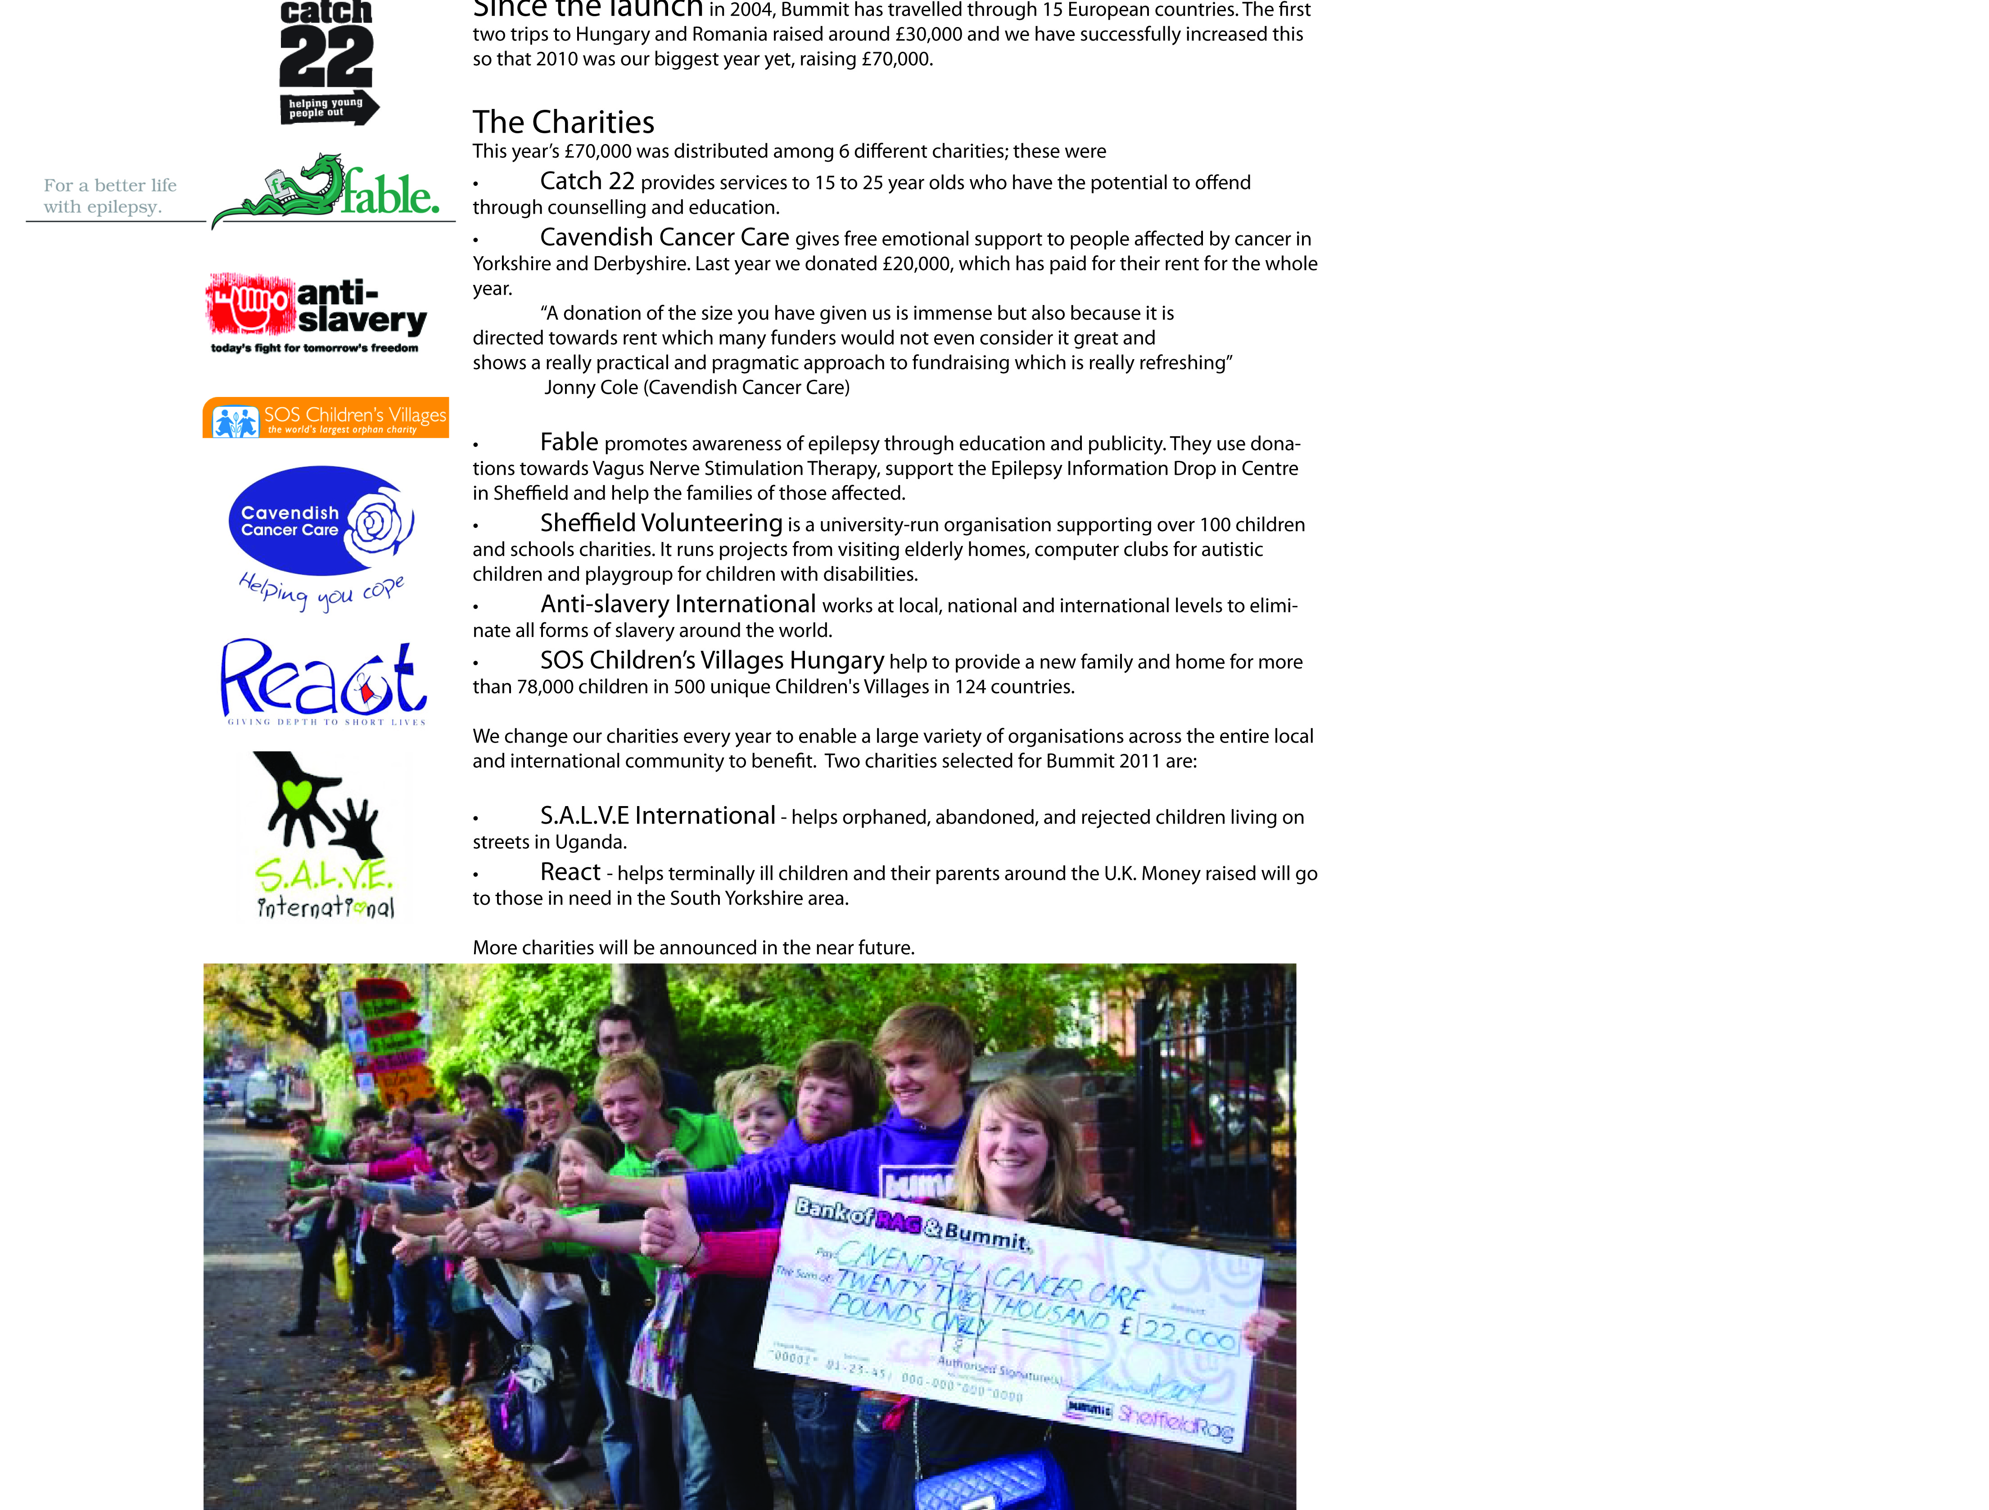

Bummit has travelled through 15 European countries and raised hundreds of thousands of pounds. Last year alone we raised £70,000 and were able to donate to the charities listed below:

• **Catch 22** provides services to 15 to 25 year olds who have the potential to offend through counselling and education.

• **Cavendish Cancer Care** gives free emotional support to people affected by cancer in Yorkshire and Derbyshire:

“A donation of the size [£20,000] you have given us is immense but also because it is directed towards rent which many funders would not even consider it great and shows a really practical and pragmatic approach to fundraising which is really refreshing”

Jonny Cole (Cavendish Cancer Care)

• **Fable** promotes awareness of epilepsy through education and publicity.

• **Sheffield Volunteering** is a university-run organisation supporting over 100 children and schools charities. It runs projects from visiting elderly homes, clubs for autistic children and playgroup for disabled children.

• **Anti-slavery International** works at local, national and international levels to eliminate all forms of slavery around the world.

• **SOS Children’s Village’s Hungary** help to provide a new family and home for more than 78,000 children in 500 centres.

We change our charities every year to enable a large variety of organisations across the entire local and international community to benefit. Two charities selected for Bummit 2011 are:

• **S.A.L.V.E International** - helps orphaned, abandoned, and rejected children living on streets in Uganda.

• **React** - helps terminally ill children and their parents around the U.K. Money raised will go to those in need in the South Yorkshire area.

More charities will be announced in the near future.